12576 Nisanth Saravanan
RIX2024-Batch 1_Code Quality & Design Principles Lab Assessment

Selected Project: Appointment Manager.
Coder: Nisanth Saravanan
Reviewer: Ranjithkumar Palanisamy

Project Description:
A MVC Project that let’s us add doctor, patient and appointment, in Razor pages.

GitHub Link:
RelevantzRIX2024/Assessments/Code Quality at 12576_Nisanth · benhar-velankanni/RelevantzRIX2024

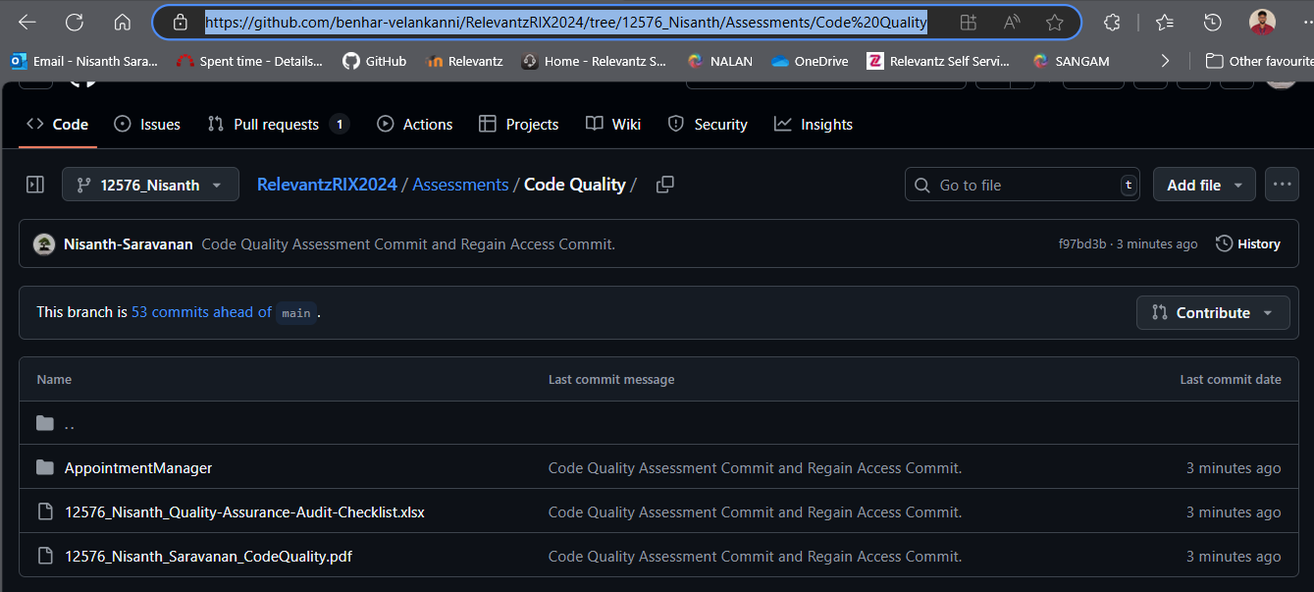

Project Output Screens:

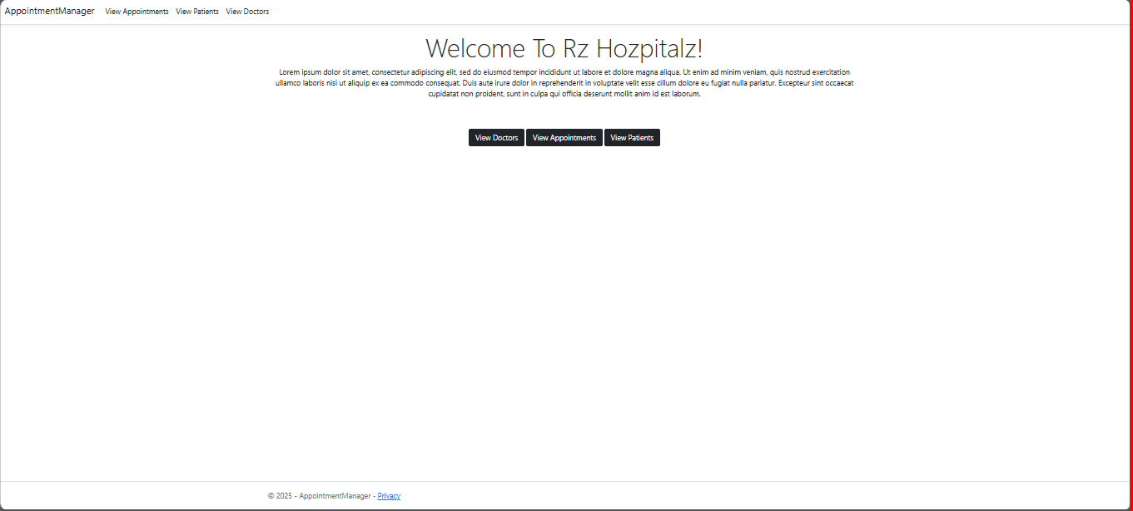

GET Method: Status: Working.

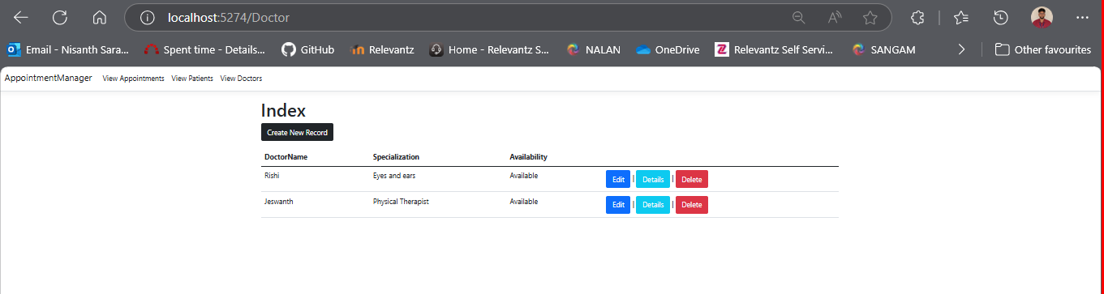

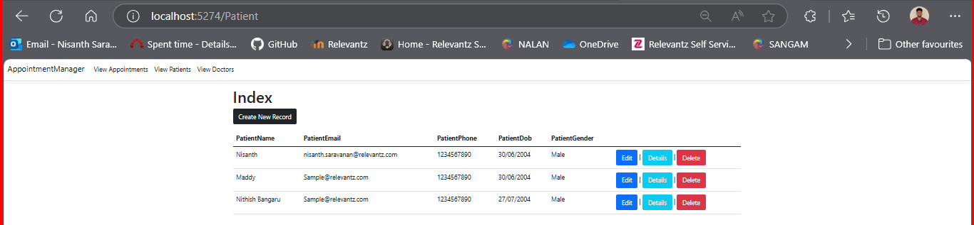

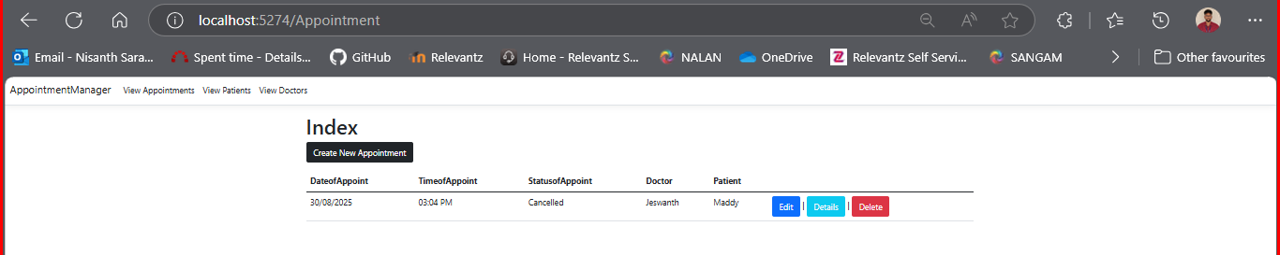
POST Method: Status: Working.

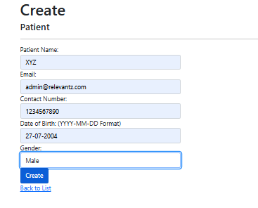

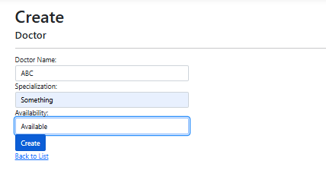

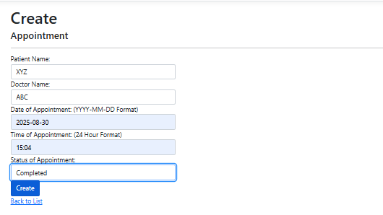
Reflection after POST:

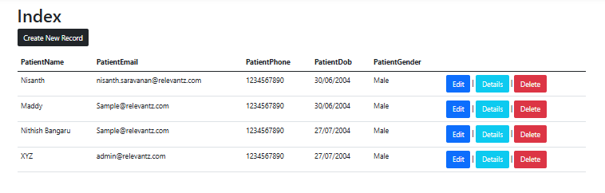

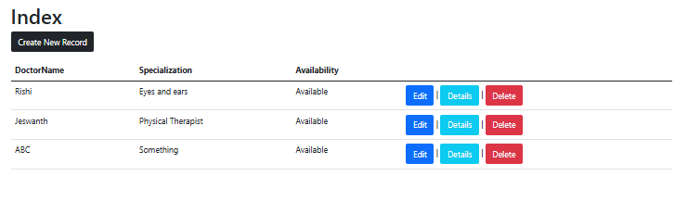

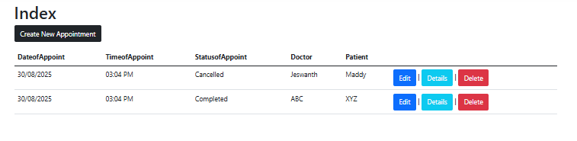
SonarQube Setup:

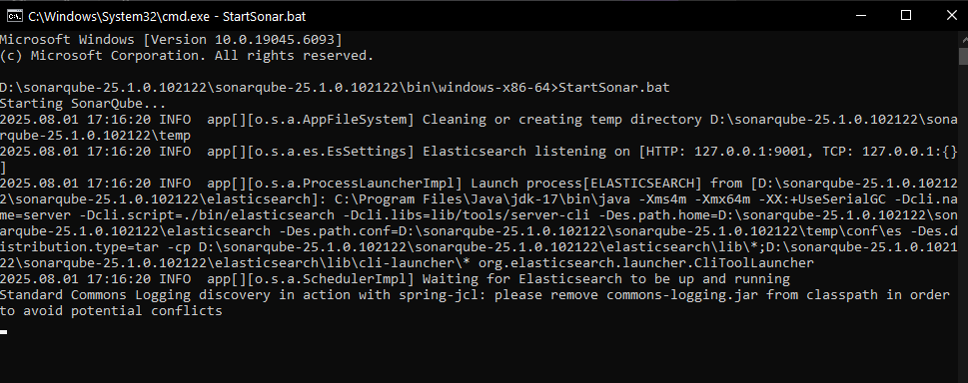

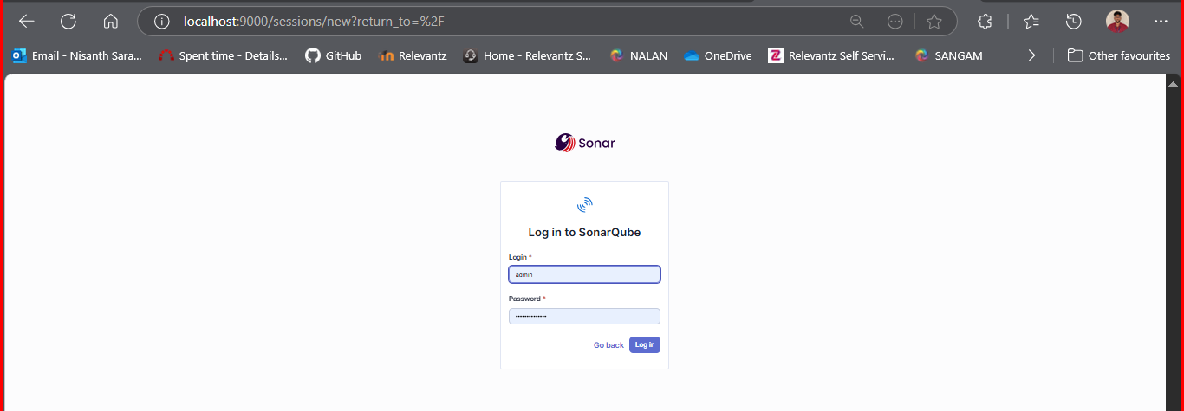

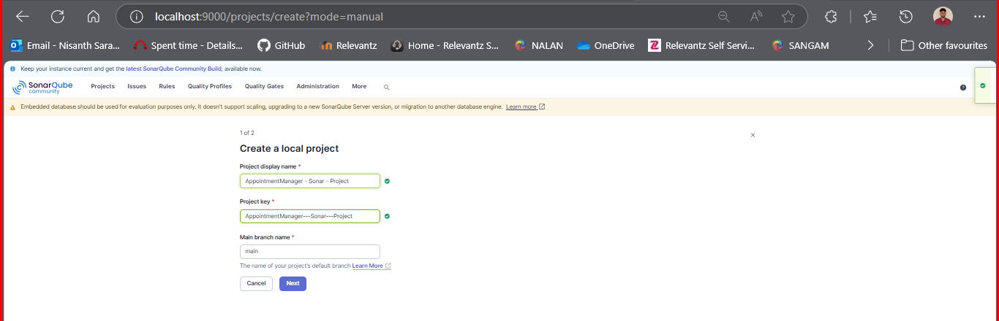
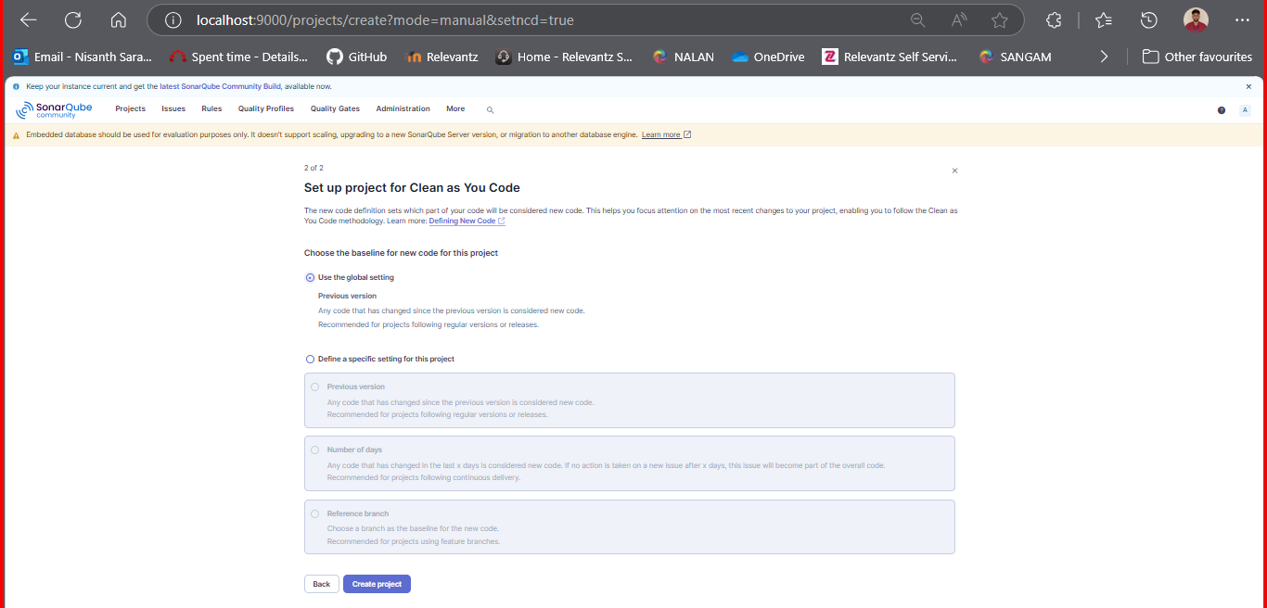

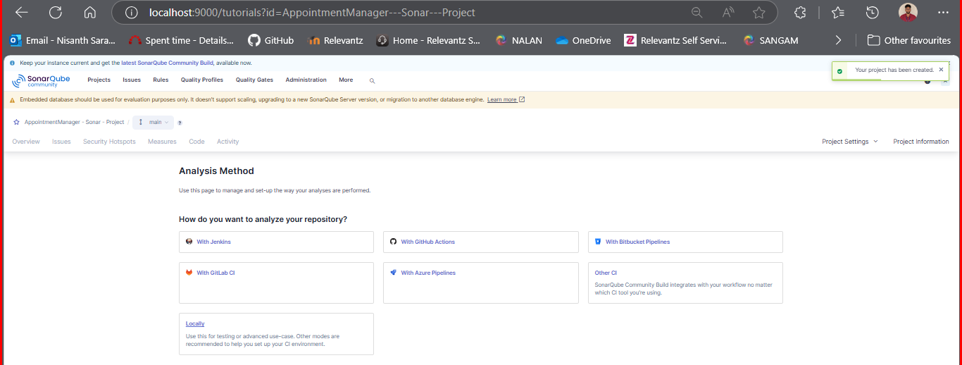

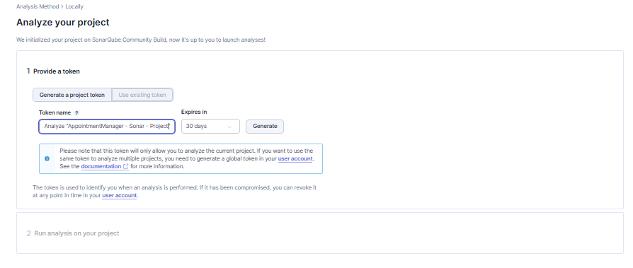
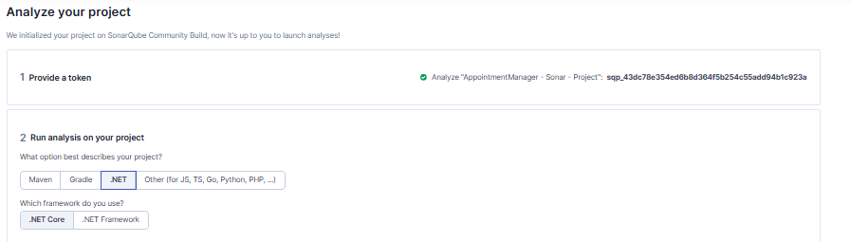

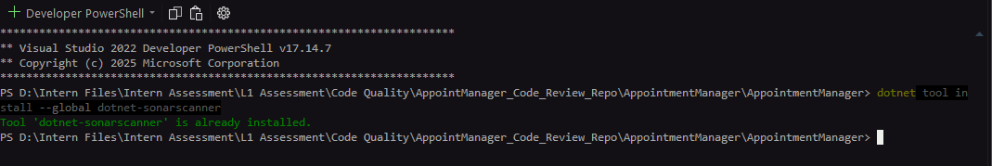

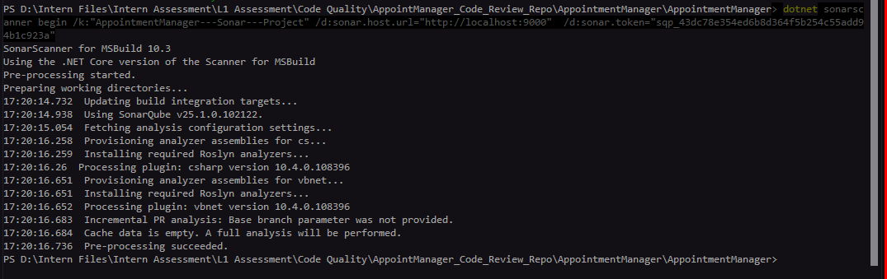

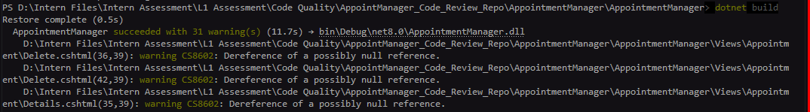

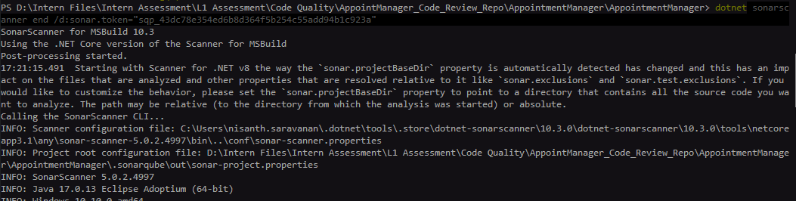

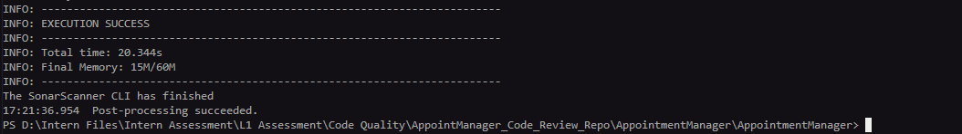

Initial SonarQube Analysis:

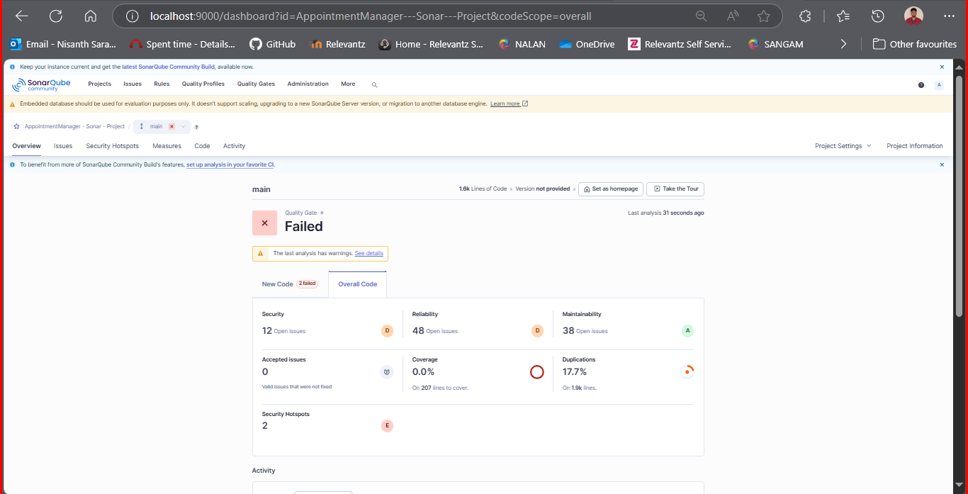


Peer-Review Comments:

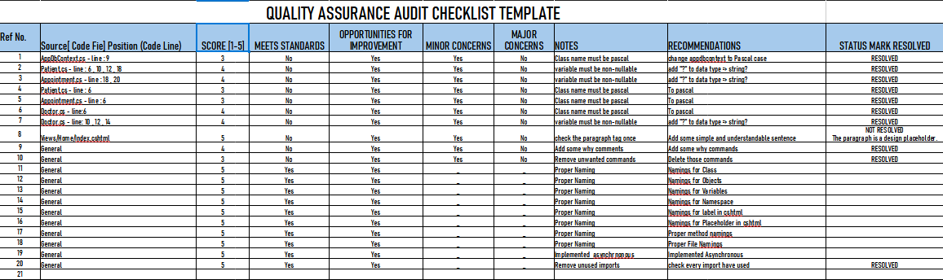

GitHub Link:

Nisanth-Saravanan/AppointManager_Code_Review_Repo

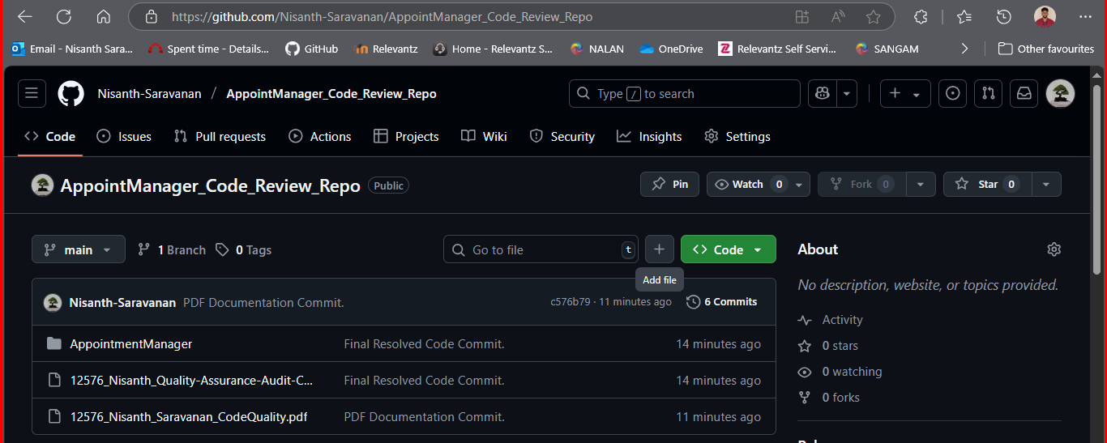
Post Refactoring SonarQube Analysis:

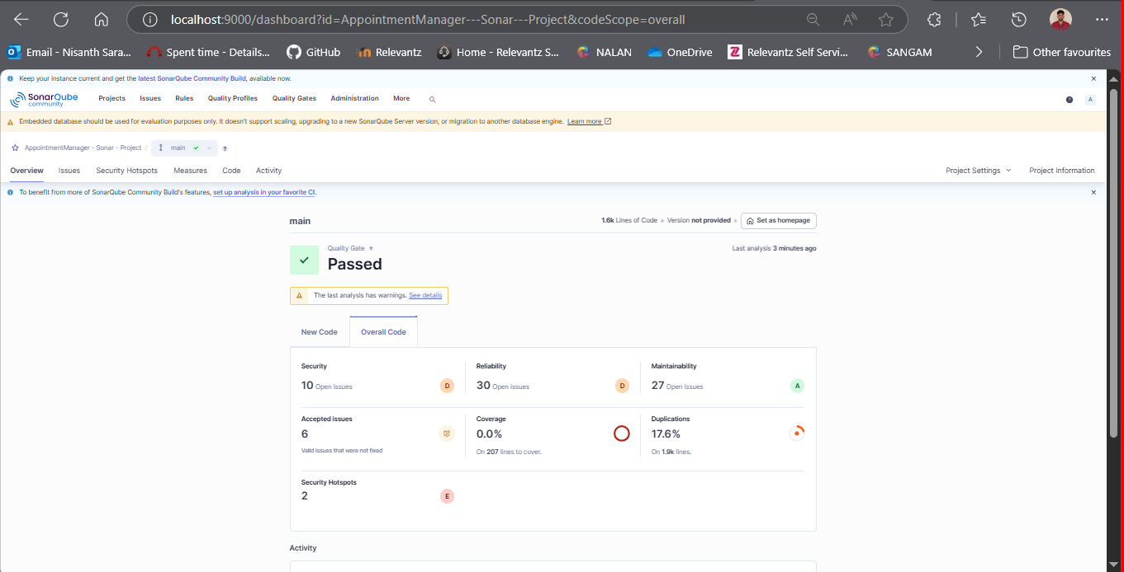


Reviewer Side Work:

